**QUESTION 1.**

**(1a)**

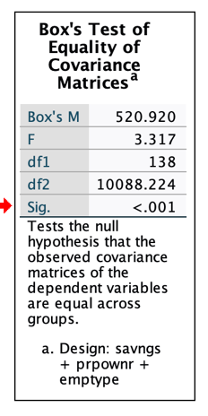

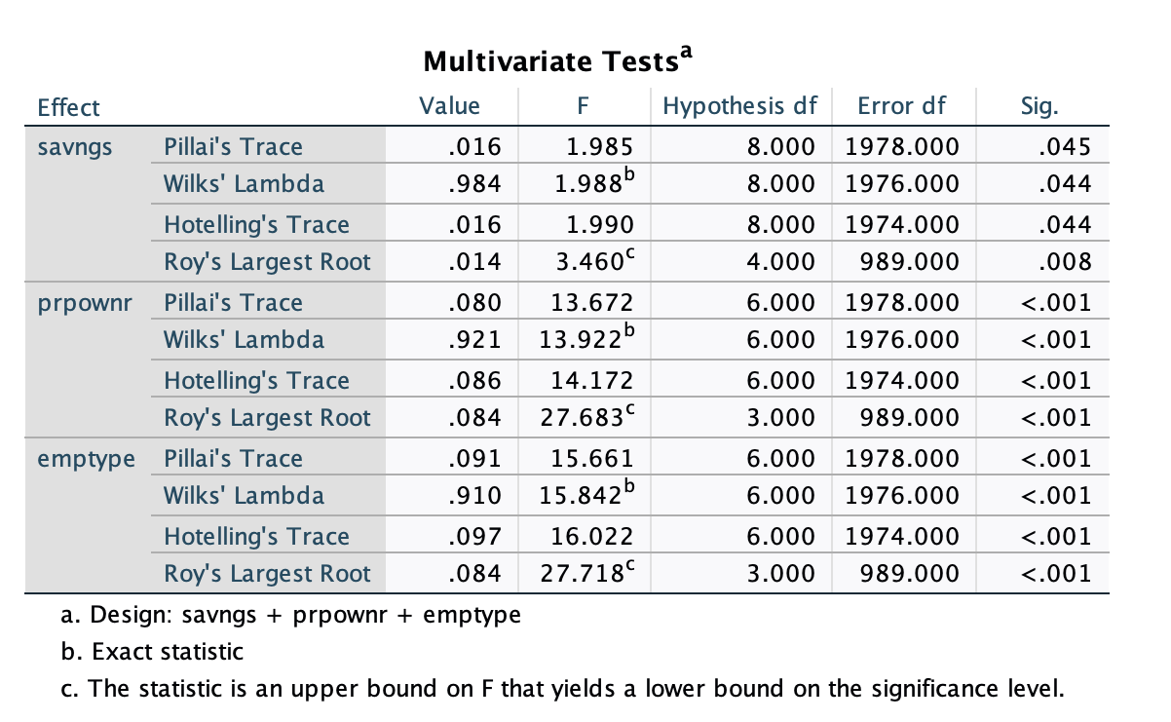

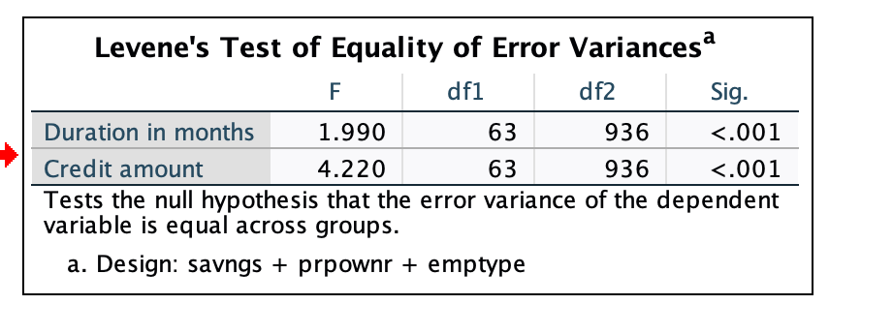

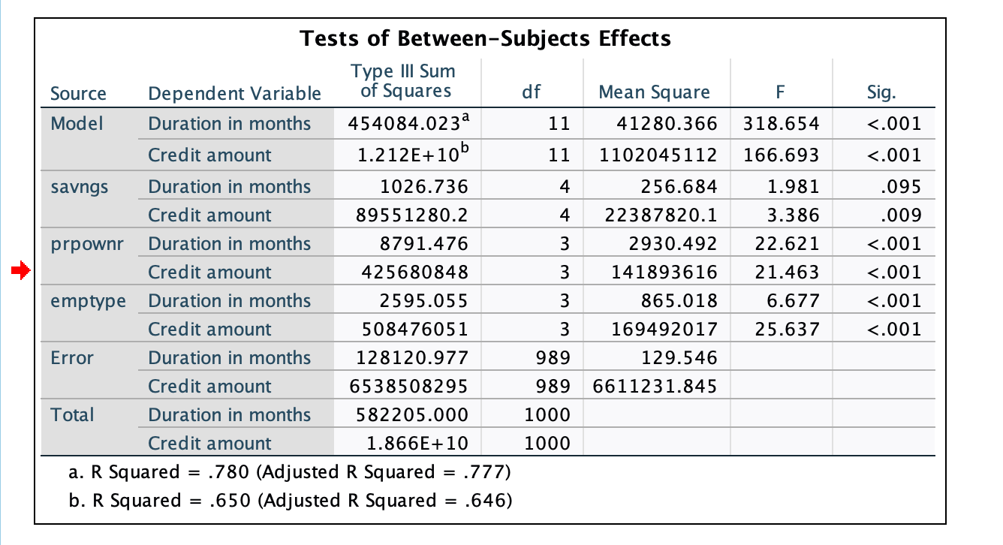

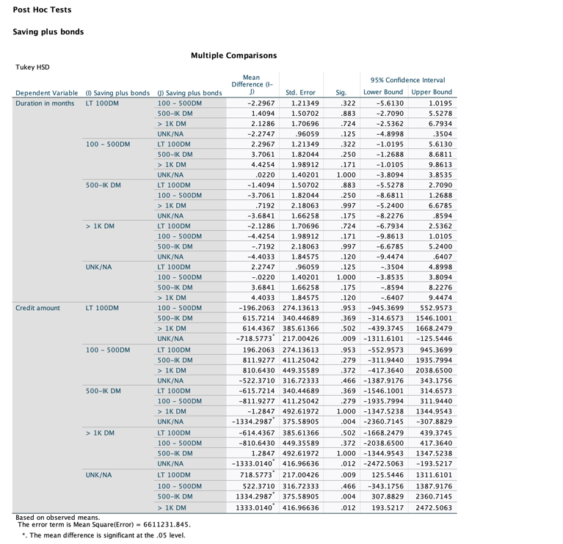

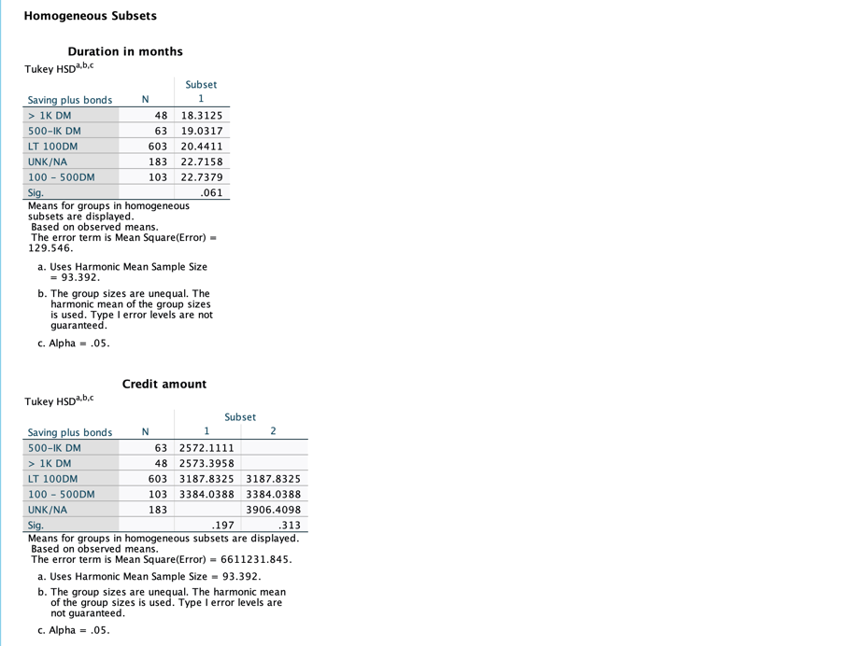

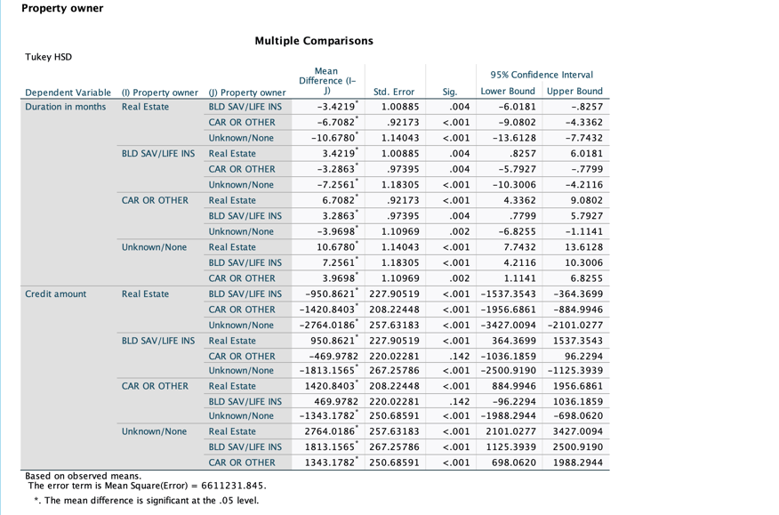

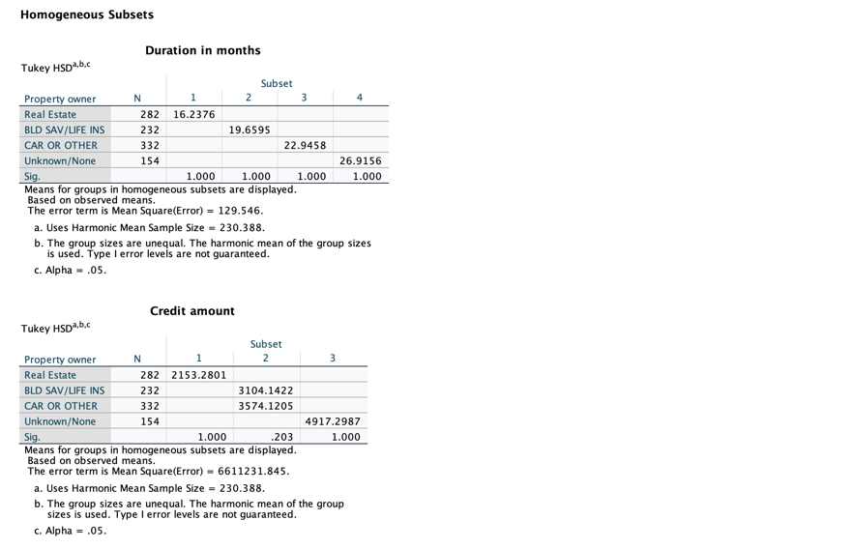

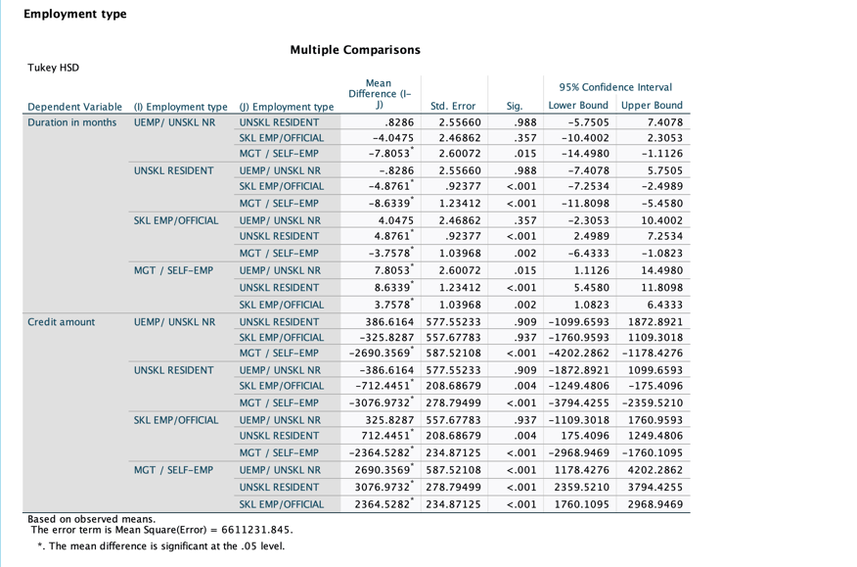

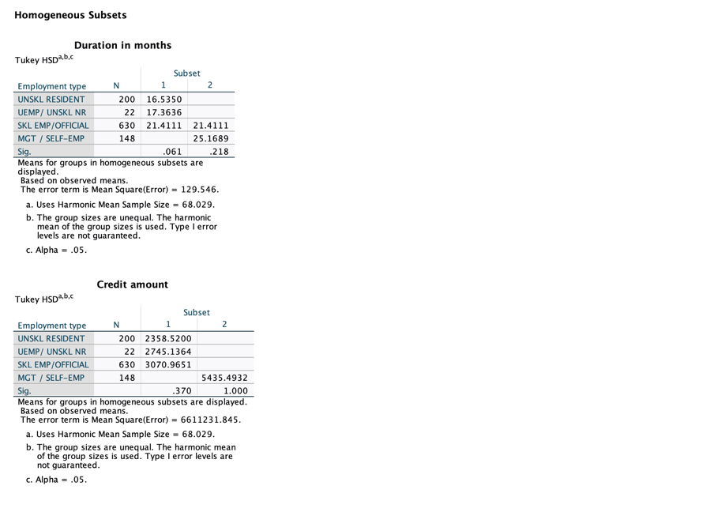

**(1b)**



***H0***: No independent variable has a significant effect on the dependent variables.

***H1***: At least one of the independent variables has a significant effect on the dependent variables.

***Observation***: From the output shown above, the Wilks’ Lambda’s tests show that the

p-values of associated with each independent variable (0.044, <0.001, <0.001) are all less than alpha = 0.05.

***Conclusion***: Thus, we reject H0 and conclude that at least one of the IVs has a significant effect on the DV.



***H0***: Homogeneity of covariances is met.

***H1***: Homogeneity of covariances is not met

Since the associated p-value for the Box’s M Test is <0.001, which is less than the desired significance level of 0.05, this suggests that homogeneity of covariances is not met.

**POST-HOC TESTS INTERPRETATION.**

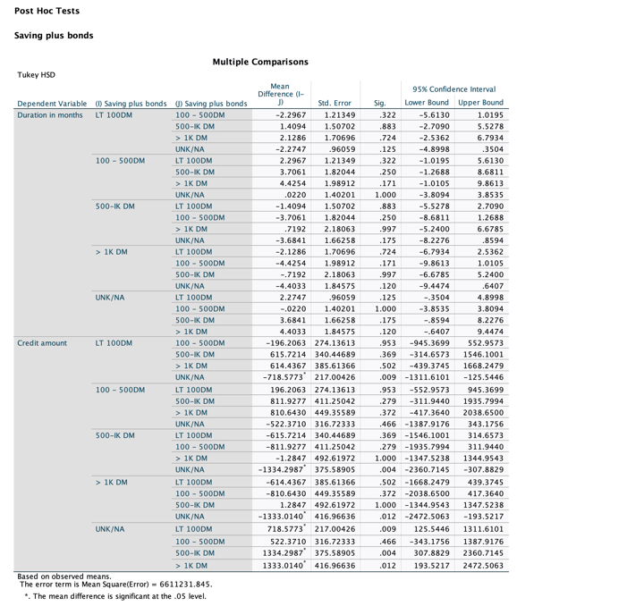

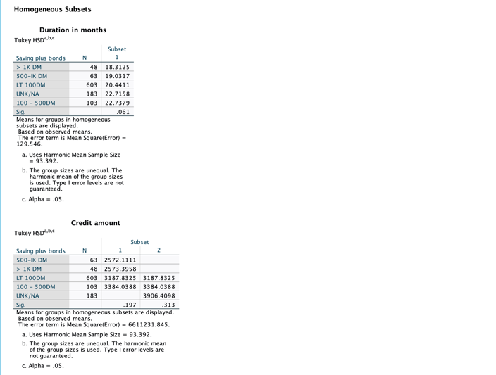

For “Saving plus bonds”, there are no significant difference between the pair of groups when accounting for “Duration in months” as the dependent variable.

However, there is a significant difference between groups (as seen for instance, in the comparison between "LT 100DM" and "UNK/NA”, which has a p-value of 0.009), when accounting for “Credit amount” as the dependent variable.

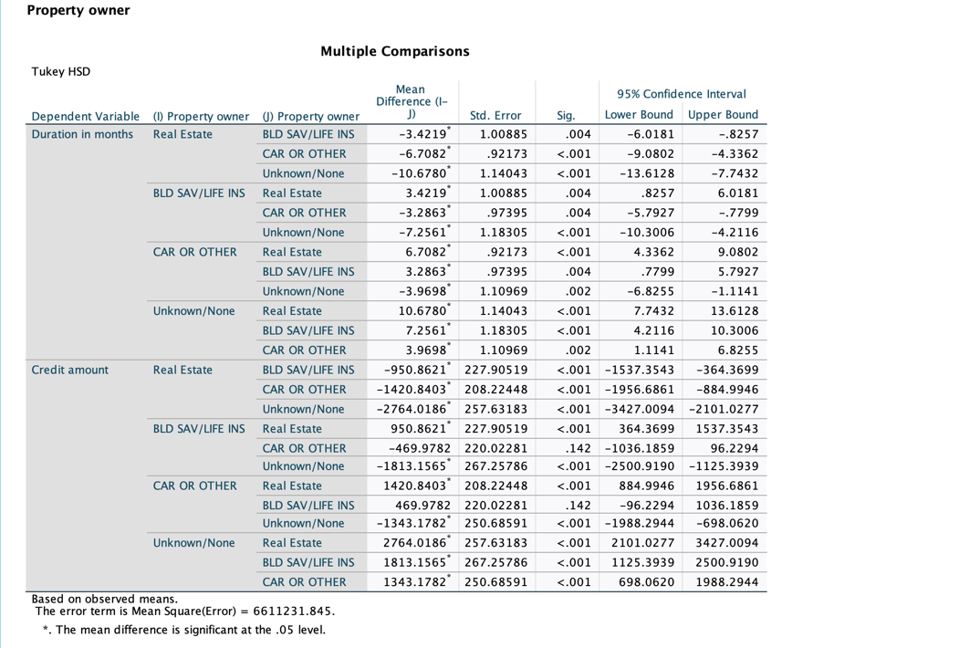

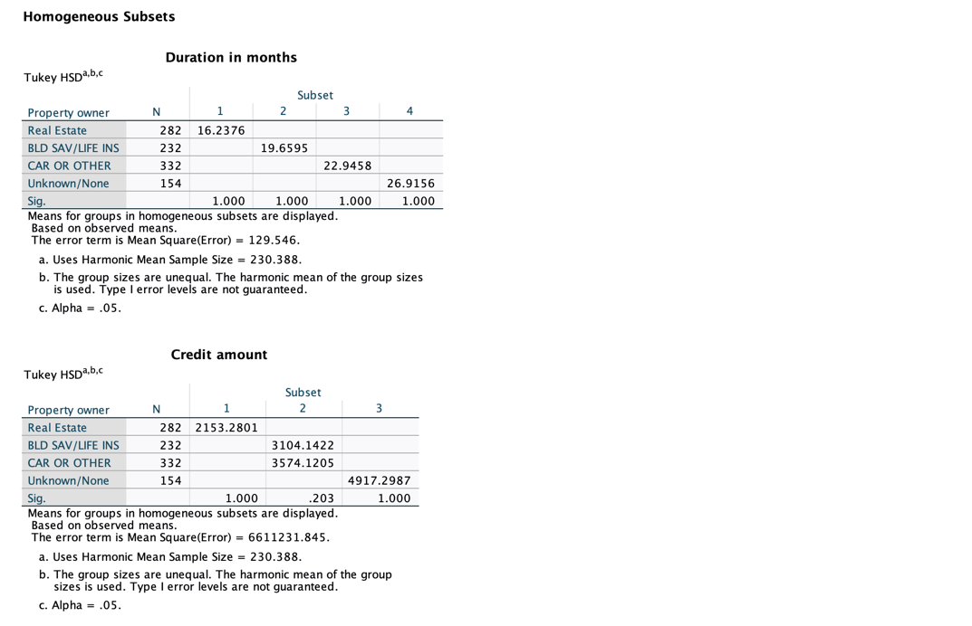

For “Property owner”, there are significant differences between the pair of groups (as seen for instance, in the comparison between "BLD SAV/LIFE INS" and "CAR OR OTHER”, which has a p-value of 0.004) when accounting for “Duration in months” as the dependent variable.

Similarly, there is a significant difference between groups (as seen for instance, in the comparison between "BLD SAV/LIFE INS" and "Real Estate”, which has a p-value of < 0.001), when accounting for “Credit amount” as the dependent variable.

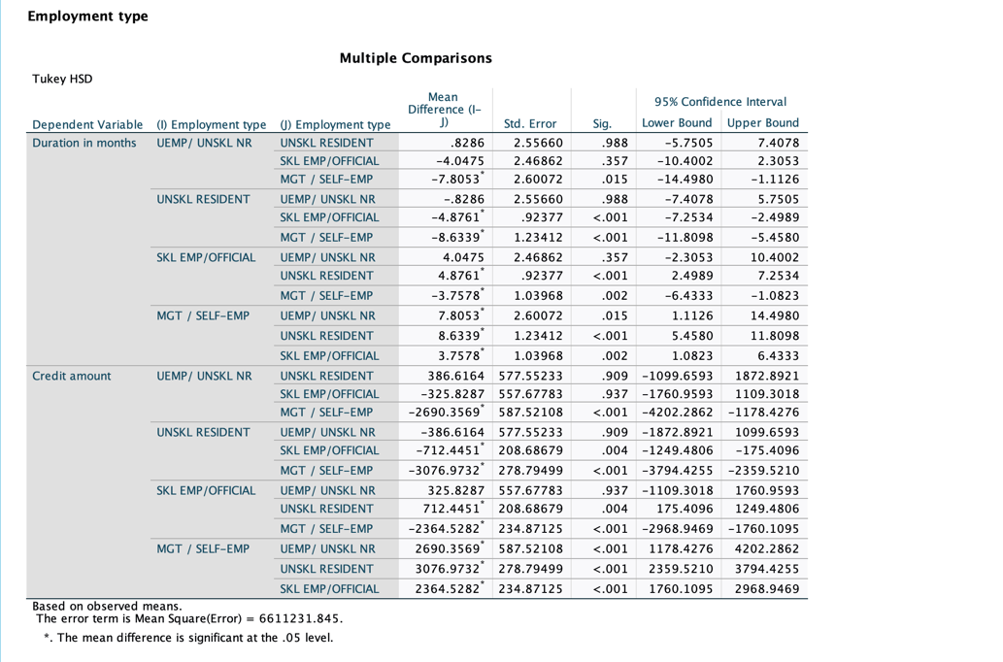

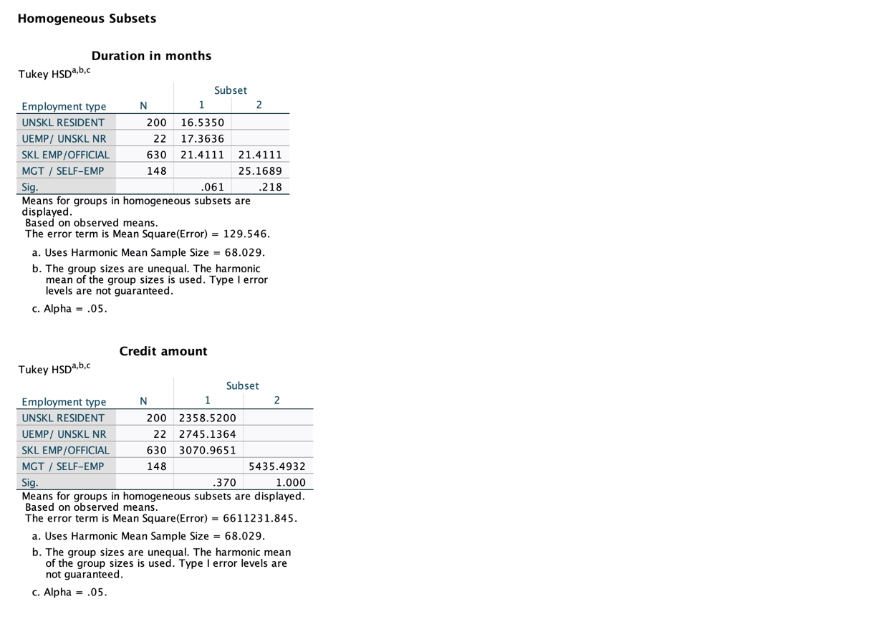

For “Employment type”, there are significant differences between the pair of groups (as seen for instance, in the comparison between "UEMP / UNSKL NR" and "MGT / SELF-EMP”, which has a p-value of 0.015) when accounting for “Duration in months” as the dependent variable.

Similarly, there is a significant difference between groups (as seen for instance, in the comparison between "SKL EMP / OFFICIAL" and "UNSKL RESIDENT”, which has a p-value of < 0.004), when accounting for “Credit amount” as the dependent variable.

**TEST OF BETWEEN-SUBJECTS EFFECTS INTERPRETATION.**



***H0***: There is no significant effect on the dependent variables by the independent variable.

***H1***: There is at least one significant effect on the dependent variables by the independent variable.

*Observation*: The associated p-value for the “Savings plus bonds” with the “Duration in months” is 0.095, which is > 0.05 alpha reference value.

Conclusion: We there fail to reject ***H0.*** Thus, there is no significant effect on the dependent variables by the independent variable